8/6/2025

**SOUTHERN UNIVERSITY OF SCIENCE AND TECHNOLOGY [SUSTECH]SCHOOL OF DESIGN**

**1. UMARU _ 12431495**

**2. 江炜韬 _ 12431497**

**3. KHOWAJA _ 12431493**

**4. 朱俊希 _ 12432460**

**INTEGRATED ROBOTIC SOLUTIONS FOR MODERN ENVIRONMENTS**

**Table of Contents**

Executive Summary 2

1- Project Overview 4

2. Conceptual Solution 1: Smart Retail Inventory Assistant Robot 5

2.1 Device Composition 5

2.2 Technical Principle 5

3. Conceptual Solution 2: Home Healthcare Companion Robot 5

3.1 Device Composition 6

3.2 Technical Principle 6

4. Conceptual Solution 3: Intelligent Companion Robot 6

4.1 Device Composition 6

4.2 Technical Principle 7

5. Solution Analysis 7

5.1 Conceptual Solution 1: Smart Retail Inventory Assistant Robot 7

5.1-1 Advantages 7

5.1-2 Disadvantages 7

5.1-3 Material Cost 7

5.2 Conceptual Solution 2: Home Healthcare Companion Robot 8

5.2-1 Advantages 8

5.2-3 Disadvantages 8

5.2-3 Material Cost 8

5.3 Conceptual Solution 3: Intelligent Companion Robot 9

5.3-1 Advantages 9

5.3-2 Disadvantages 9

5.3-3 Material Cost 10

6. Solution Comparison 10

6.1 Technical Comparison 10

6.2 Cost Comparison 11

6.3 Summary 11

6.4 Conclusion 12

Appendix 1 13

Reference 19

# **Executive Summary**

This report, *Integrated Robotic Solutions for Modern Environments*, presents a comparative study of three cutting-edge robotic systems tailored for distinct use cases: retail inventory management, home healthcare, and interactive companionship. Each solution is rooted in a shared architecture leveraging autonomous navigation, real-time sensor fusion, and edge AI computing, but is uniquely optimized for its target environment.

* Smart Retail Inventory Assistant Robot is engineered to automate shelf audits and stock monitoring in retail environments. It integrates RFID/barcode scanning, RGB-D vision, and SLAM-based navigation to deliver high-throughput, real-time inventory analytics. Designed for scalability, it supports multi-robot fleet deployment, though it requires significant infrastructure calibration and RFID integration.
* Home Healthcare Companion Robot addresses the growing need for aging-in-place support. With fall detection via ToF sensors, wearable vitals monitoring, and conversational AI for medication reminders and emergency handling, it provides holistic, non-invasive care. Its plug-and-play integration with smart home systems and emphasis on passive monitoring reduce caregiver load. However, privacy and regulatory hurdles remain key challenges.
* Intelligent Companion Robot emphasizes natural interaction and multimodal user engagement. It utilizes spherical mobility, panoramic vision, directional audio sensing, and GPT-lite NLP for real-time speech and facial recognition. This makes it ideal for dynamic, interactive environments like smart homes, hospitality, or educational spaces. Though less sensor-intensive, it offers high usability and adaptability at a modest cost.

***Key Findings***

* All systems rely on modular designs and share a core AI and sensor backbone, enabling adaptability and cost-effective scaling.
* The Retail Robot excels in commercial precision and throughput.
* The Healthcare Robot provides the most comprehensive physiological monitoring.
* The Companion Robot offers superior human robot interaction and contextual responsiveness.

***Final Decision***

After technical and cost evaluation, the Intelligent Companion Robot was selected as the most suitable solution for deployment. It balances affordability, user interactivity, low deployment complexity, and broad applicability across consumer and public domains.

Word Count: 2805

# **Project Overview**

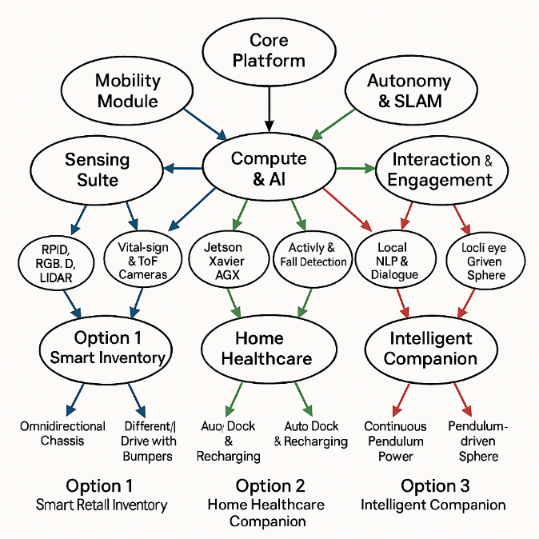This project explores three state-of-the-art autonomous robotic systems developed for retail automation, home healthcare, and interactive companionship, all built on a shared foundation of autonomous navigation, sensor fusion, and edge AI processing. Despite addressing distinct sector-specific challenges, the robots leverage a common architecture featuring advanced sensing (e.g., RFID, 3D cameras, vital-sign wearables, beamforming audio), real-time inference using platforms like NVIDIA Jetson or FPGA, and robust localization and navigation via SLAM and UWB. Designed with human-centric principles, each system ensures intuitive interaction, safety, and minimal setup. Together, these solutions demonstrate the modularity and scalability of intelligent robotics across diverse real-world applications.

*Fig1: Holistic Schematic of an Intelligent Robot system*

# **2. Conceptual Solution 1: Smart Retail Inventory Assistant Robot**

The Smart Retail Inventory Assistant Robot is an autonomous robotic system that revolutionizes in-store inventory management by automating shelf monitoring, ensuring pricing accuracy, and enhancing operational efficiency. Equipped with advanced sensors and AI capabilities, this robot navigates retail environments to provide real-time data on stock levels and shelf conditions.

## **2.1 Device Composition**

* **Mobility**: Omnidirectional four-wheel chassis with high-precision encoders and UWB (Ultra-Wideband) beacons for sub-decimeter positioning.
* **Sensing**:
  1. Dual-mode RFID/barcode scanner capable of >700 reads/sec.
  2. Intel RealSense RGB-D depth cameras with HDR and autofocus for shelf mapping.
  3. 4K high-res optical camera for product and label verification.
* **Compute**: NVIDIA Jetson AGX Xavier (32 TOPS AI performance) with auxiliary FPGA for real-time sensor fusion.
* **Power**: 8-hour rechargeable lithium-ion battery with automated conductive docking.
* **Connectivity**: Dual-band Wi-Fi, LTE backup, and secure cloud interface.

## **2.2 Technical Principle**

Utilising SLAM (Simultaneous Localisation and Mapping), the robot autonomously navigates retail aisles and constructs real-time 3d maps using fused Lidar and vision data. The integrated RFID/barcode system provides a fast, reliable product ID. Edge compute executes CV models like YOLOv7 for the segmentation of untagged items. Depth cameras detect shelf fill levels and discrepancies, while insights are uploaded for real-time dashboard alerts and predictive restocking analytics.

# **3. Conceptual Solution 2: Home Healthcare Companion Robot**

The Home Healthcare Companion Robot is an autonomous, mobile solution designed for aging‑in‑place, combining telepresence, health monitoring, and interactive engagement to assist seniors in home environments [1]. It integrates 3D time‑of‑flight sensing for fall detection, wearable IoT sensors for real-time vital‑sign monitoring (ECG, SpO₂, heart rate), and transformer-based conversational AI to deliver medication reminders, social activities, and emergency calling [2], [3]. With edge‑compute modules for on-device inference and secure cloud services for remote analytics and telehealth integration, the system reduces caregiver burden and enhances patient safety and wellness at home [4].

## **3.1 Device Composition**

* **Mobility**: Compact differential-drive base (Jetson Nano + Raspberry Pi 4) designed for indoor navigation.
* **Sensing**:
  1. 3D Time-of-Flight (ToF) camera for posture detection and fall recognition.
  2. Wearable BLE vital-sign band monitoring ECG, SpO2, and heart rate.
  3. Voice/audio subsystem: omnidirectional mic array with speaker.
  4. Environmental sensors (temperature, humidity, air quality).
* **Compute**: Jetson Nano for AI inference; RPi4 for UI and peripheral management.
* **Integration**: Zigbee/Z-Wave for smart-home interaction.
* **Power**: 10-hour rechargeable battery with docking support.

## **3.2 Technical Principle**

Combining data from ToF cameras and BLE wearables, the system uses CNNs (MobileNetV3) for motion detection and LSTMs for vital-sign anomaly prediction. NLP engine (DistilBERT) drives conversational prompts for medication reminders, health check-ins, and emergency interactions. Edge inference reduces latency, while secure cloud APIs support health trend analytics and caregiver dashboards.

# **4. Conceptual Solution 3: Intelligent Companion Robot**

The Intelligent Companion Robot is an AI-driven, interactive mobile platform capable of seamlessly navigating indoor environments while engaging users through natural language interaction and multimodal perception [5]. Leveraging advanced mobility mechanisms such as pendulum-actuated spherical drives or differential‑drive bases with SLAM localization, it adapts to cluttered spaces and autonomously follows or guides users on demand [6]. Equipped with 360° fisheye cameras, directional microphone arrays for beamforming, and onboard GPUS for real-time vision and audio processing, it achieves precise target tracking and voice localization even in noisy environments. Transformer-based NLP models run locally to handle conversational queries, reminders, and interactive dialogues, enabling personalized assistance without requiring constant cloud connectivity [7]. Modular software stacks based on ROS 2 orchestrate sensor fusion, navigation, and dialogue management, while optional cloud services provide analytics, model updates, and remote monitoring capabilities.

## **4.1 Device Composition**

* **Mobility**: Pendulum-actuated spherical shell enabling omnidirectional agility.
* **Sensing**:
  1. 360° fisheye camera with real-time image rectification.
  2. Directional microphone array with MVDR beamforming.
* **Compute**: NVIDIA Jetson AGX Xavier.
* **Connectivity**: Wi-Fi + BLE; low-latency local control.
* **Power**: 6-hour lithium-ion battery with magnetic docking station.

## **4.2 Technical Principle**

Fisheye-based SLAM corrects distorted panoramic images for continuous environment mapping. Internal pendulum motion enables dynamic stabilization and agile movement. Voice beamforming precisely locates user intent. Locally deployed GPT-lite NLP handles user queries and proactive conversational flows.

# **5. Solution Analysis**

## **5.1 Conceptual Solution 1: Smart Retail Inventory Assistant Robot**

### **5.1-1 Advantages**

* 1. ***High throughput****: Scans entire store in < 2 hours; continuous operation via automated recharging.*
  2. ***Multimodal accuracy****: Combines RFID and CV to detect tagged and untagged items in diverse fixtures* [8]*.*
  3. ***Scalability****: Fleet management for synchronized multi-robot deployments.*

### **5.1-2 Disadvantages**

* 1. ***Infrastructure dependency****: Performance degrades without RFID tags or stable Wi‑Fi.*
  2. ***Initial calibration****: Mapping and sensor‑fusion tuning require on-site commissioning.*

### **5.1-3 Material Cost**

|  |  |  |  |
| --- | --- | --- | --- |
| **Component Category** | **Specific Component** | **Purpose** | **Estimated Cost (RMB)** |
| **Mobility System** | 4-Wheel Omnidirectional Chassis with Encoders | Allows precision movement and SLAM-based navigation | ¥1169 |
| **Localization Module** | UWB Anchors + Tags (Pozyx / Decawave) | Indoor localization with ~10 cm accuracy | ¥69 |
| **Sensing - RFID & Barcode** | Impinj R700 RFID Reader + Zebra Barcode Scanner | Inventory ID for tagged and untagged items | ¥2094 |
| **Vision System** | Intel RealSense D455 RGB-D Camera | Shelf depth and geometry mapping | ¥872.58 |
| **Compute Unit** | FPGA Module (Xilinx Spartan or Kintex series) | Real-time sensor data fusion | ¥3329 |
| **Power System** | 8-hour Li-ion Battery Pack (48V 15Ah) | Supports full shift operation | ¥281.58 |
| **Networking** | Industrial Dual-Band Wi-Fi Module + LTE Modem | Real-time cloud sync and redundancy | ¥469.58 |
| **Framework & Software** | ROS 2 + Custom SLAM & Inventory Management Software | Navigation, SLAM, and SKU processing | ¥3,000 – ¥5,000 (dev time/licensing) |
| **Enclosure & Safety** | Custom Enclosure (ABS, Aluminium Frame with Bumpers) | Structural integrity and shopper safety | ¥500 – ¥1,000 |
| **Misc. Accessories** | Cables, Mounts, Cooling Fans, EMI Shielding | Required for integration and operation | ¥50 – ¥100 |

## **5.2 Conceptual Solution 2: Home Healthcare Companion Robot**

### **5.2-1 Advantages**

* 1. ***Holistic care****: combines passive monitoring with active engagement to enhance independence and reduce loneliness.*
  2. ***Plug‑and‑play****: minimal installation; integrates seamlessly with existing smart‑home devices.*
  3. ***Data‑driven insights****: aggregated trends inform remote care planning.*

### **5.2-3 Disadvantages**

* 1. ***Privacy concerns****: constant monitoring raises data‑security and consent issues.*
  2. ***Regulatory hurdles****: medical‑grade monitoring may require FDA/CE certification.*

### **5.2-3 Material Cost**

|  |  |  |  |
| --- | --- | --- | --- |
| Component Category | Description | Example Model / Specs | Estimated Cost (RMB) |
| Mobility Base | Differential-drive indoor mobile base | 2-wheel chassis with encoder motors, caster wheel, battery mount | ¥1769 |
| Compute Core | AI inference + control logic | Jetson Nano (AI) + Raspberry Pi 4 (UI & I/O control) | ¥3909 (Nano) + ¥488.58 (RPi) |
| ToF Depth Camera | 3D vision for fall detection and posture tracking | Orbbec Astra / Intel RealSense D435 | ¥852 |
| BLE Vital-Sign Wearable | Monitors ECG, SpO₂, and heart rate via wristband | China-made BLE smart band with SDK (e.g., Zepp Health) | ¥355.38 |
| Microphone Array + Speaker | Voice interaction and emergency command recognition | 6-mic array + 3W speaker module (e.g., ReSpeaker, Seeed Studio) | ¥511 |
| Environmental Sensors | Home comfort sensing (temperature, humidity, CO₂/TVOC) | DHT22 + CCS811 sensor combo | ¥23.65+  ¥187.58 |
| Smart Home Interface | Zigbee/Z-Wave for home device control | Zigbee2MQTT hub or similar | ¥29.57 |
| Battery System | Rechargeable lithium battery with docking support | 12V 12Ah Li-ion + charger/dock | ¥95 |
| Chassis Enclosure & Frame | Robot housing, sensors integration, and user-friendly finish | ABS shell with modular mounts | ¥500 – ¥1,000 |

## **5.3 Conceptual Solution 3: Intelligent Companion Robot**

### **5.3-1 Advantages**

* 1. **Holistic care**: combines passive monitoring with active engagement to enhance independence and reduce loneliness.
  2. **Plug‑and‑play**: minimal installation; integrates seamlessly with existing smart‑home devices.
  3. **Data-driven insights**: aggregated trends inform remote care planning.

### **5.3-2 Disadvantages**

* 1. **Privacy concerns**: constant monitoring raises data‑security and consent issues.
  2. **Regulatory hurdles**: medical‑grade monitoring may require FDA/CE certification.

### **5.3-3 Material Cost**

|  |  |  |  |
| --- | --- | --- | --- |
| Component Category | Component | Description | Estimated Cost (RMB) |
| Mobility System | High-efficiency motor controller (BLDC) | Brushless DC motors and driver for smooth pendulum adjustment, XTARK STM32 intelligent car | ¥549 |
| Vision System | Real-time Image Rectification Processor | Embedded hardware/software for fisheye distortion correction, Seeed Studio XIAO ESP32 S3 Sense | ¥144.23 |
| Audio System | Audio amplifier module | Supports beamforming and voice-source localization, MAX98357A | ¥79 |
| Ultrasonic System | Ultrasonic ranging sensor | Ultrasonic ranging enables the car to travel at a safe speed,HC-SR04 | 29 |
| Compute Unit | Secondary Microcontroller (STM32 or Raspberry Pi Pico) | Manages non-AI tasks such as motion control, I/O bridging, OpenCTR H60 STM32 | ¥268 |
| Power System | Magnetic Docking Station | Automatic charging base | ¥42 |
| Chassis & Materials | CNC Machined Frame, Transparent Dome Shell | Structural and aesthetic components, build by ourselves | ¥0 |

# **6. Solution Comparison**

## **6.1 Technical Comparison**

|  |  |  |  |
| --- | --- | --- | --- |
| Feature / Aspect | Smart Retail Robot | Healthcare Companion Robot | Intelligent Companion Robot |
| Primary Application | Automated inventory audits in retail environments | Elderly care: health monitoring, telepresence | Interactive engagement in home/hospitality spaces |
| Mobility Platform | Omnidirectional UWB-enabled chassis | Differential-drive, optimized for indoor flat floors | Pendulum-actuated spherical shell for agility |
| Navigation & SLAM | LiDAR + RGB-D + UWB + Cartographer (ROS 2) | ToF + inertial SLAM (indoor) | Fisheye + vision-only SLAM with omnidirectional tracking |
| Core AI Models | YOLOv7 (CV), Shelf mapping, barcode/RFID fusion | MobileNetV3 (fall detection), LSTM (vitals), NLP | Multimodal fusion: GPT-lite + CV + voice beamforming |
| Sensor Fusion | FPGA-aided fusion of vision, RFID, and depth | BLE + vision + environmental context | Visual + spatial audio beamforming |
| Human Interaction | Minimal (dashboard/alerts for staff) | Conversational (reminders, wellness, alerts) | Natural speech, facial focus, and user localization |
| Scalability | High (multi-robot fleet deployment in retail chains) | Moderate (individual home units with cloud integration) | Moderate (single or distributed units with NLP) |
| Environment Suitability | Large retail stores with structured layouts | Senior homes, clinics, and personal residences | Smart homes, museums, small hotels, and exhibitions |

## **6.2 Cost Comparison**

|  |  |  |  |
| --- | --- | --- | --- |
| Category | Retail Robot | Healthcare Robot | Companion Robot |
| Material Cost (RMB) | ¥11834.74 – ¥14384.74 | ¥8720.76–  ¥9220.76 | ¥1111.23 |
| Annual Processing Cost | ¥500 – ¥1000 | ¥500 – ¥1000 | ¥0 |
| Scalability Factor | High (fleet rollouts) | Medium (independent units) | Medium (adaptive deployments) |
| Deployment Complexity | Medium to High (mapping + tags) | Low to Medium (wearables + apps) | Medium (voice personalization) |

# **6.3 Summary**

Each robotic solution is purpose-built but rooted in a shared modular and intelligent architecture. Here is how they compare for real-world deployment:

* Smart Retail Inventory Robot is optimized for large-scale commercial automation, especially in environments where accuracy, inventory turnover, and RFID infrastructure are priorities. Long-term efficiency gains justify its high upfront investment, especially across multi-store networks.
* The Home Healthcare Companion Robot is designed for elderly safety and assisted living. It offers the most comprehensive sensor integration for health monitoring and is ideal for scenarios where passive detection, emergency response, and telehealth interoperability are required. However, it involves higher regulatory scrutiny due to medical-grade sensors.
* Intelligent Companion Robot offers the most immersive human–robot interaction, excelling in natural language processing, facial/user tracking, and multimodal response. It suits smart environments like homes, museums, hotels, or educational spaces. With mid-range costs and high perceived interactivity, it is the best fit for applications prioritizing user engagement and adaptability.

# **6.4 Conclusion**

These three solutions collectively demonstrate the viability and potential of intelligent robots tailored for everyday environments, from commercial spaces to private homes. Integrating robotics, artificial intelligence, and human-centred design heralds a new era in which autonomous systems serve as tools and collaborative assistants that can reshape industries, enhance quality of life, and redefine productivity. The Retail Robot excels in operational scale and precision, the Healthcare Robot focuses on patient monitoring and wellness, and the Companion Robot is distinguished by its natural, human-like interaction. The decision was made to select **Companion Robot**, which aligns most effectively with the intended application, infrastructure readiness, compliance requirements, and project budget and timeline, with details from building the framework to model output as illustrated appendix 1.

# **Appendix 1**

* + 1. **Framework Design Using Open-Source Solutions**

To initiate the project, relevant motion models and 3D design references were gathered from open-source platforms. These resources helped shape the foundational architecture of robotic vehicles.

|  |  |
| --- | --- |
|  |  |
| **Figure 1.** Open-source 3D model used for structural reference | **Figure 2.** Prototype concept obtained from open-source resources |

**2. Intelligent Following System Framework**

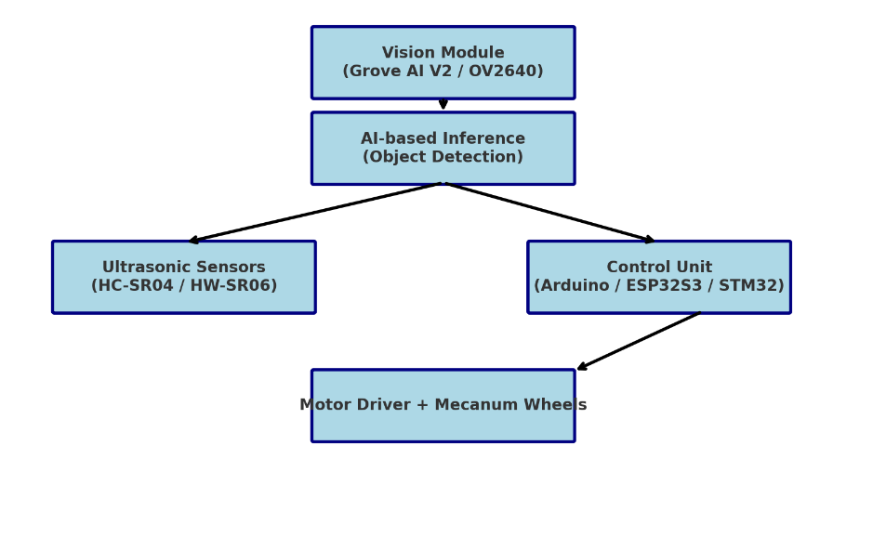A comprehensive project framework was developed focusing on an intelligent following system. This integrates Arduino and AI-based self-training models for autonomous navigation and obstacle detection.

**Figure 3.** System Architecture Diagram

**Key Components:**

* **Ultrasonic Sensors:** HC-SR04, HW-SR06
* **Control Units:** Arduino, STM32, XIAO ESP32S3
* **Mobility:** Mecanum wheels, rubber tires, TT motors
* **Vision Systems:** OV2640, Grove Vision AI V2, ESP32S3 Vision Module

**3. Component Acquisition and Testing**

Essential electronic and mechanical components were purchased and tested to ensure compatibility and performance prior to assembly.

|  |  |
| --- | --- |
|  |  |
| **Figure 4.** Arduino UNO R3 | |
|  |  |
| **Figure 5.** Arduino UNO R3 expansion board | **Figure 6.** Grove Vision AI V2 |

|  |  |
| --- | --- |
|  |  |
| **Figure 7.** OV5647-62 | **Figure 8.** Ultrasonic sensors (HW-SR06, HC-SR04) |
|  |  |
| **Figure 9.** Mecanum wheels | |
|  | |
| **Figure 10.** TT motors | |
|  | |
| **Figure 11.** 3.7V lithium battery used for power supply | |

**4. 3D Modeling and Printing**

Mechanical parts such as sensor brackets, shell, and base were designed using CAD software. These models were sliced and printed using a 3D printer.

|  |  |
| --- | --- |
|  | |
| **Figure 12.** CAD model of the sensor bracket | |
|  |  |
| **Figure 14.** Shell and base design | |
|  | |
| **Figure 15.** Model slicing process for 3D printing | |
|  | |
| **Figure 16.** Final 3D printed parts | |

**5. Assembly of Components**

All hardware components were assembled into a functional prototype. Electrical connections were established, and modules were integrated into the chassis.

**(To be added: Figure 13. Assembled robotic car prototype)**

**6. System Testing and Validation**

The fully assembled robot was tested for functionality, including sensor accuracy, mobility, and object-following behavior. Software code execution was verified through onboard diagnostics.

**(To be added: Figure 14. Screenshot of Arduino/ESP32 code during testing)**

# **Reference**

[1] “Blue Frog Robotics - Buddy_ The Companion Robot Transforming Senior Care with AI.”

[2] Z. Ayn, V. S. Venimitra, J. Joy, S. Varghese, and R. M. A. S, “Revolutionizing Healthcare : A Comprehensive Survey of Robotics and Wearable Sensors,” vol. 13, no. 1, pp. 69–73, 2024.

[3] J. V Vaghasiya, C. C. Mayorga-Martinez, and M. Pumera, “Wearable sensors for telehealth based on emerging materials and nanoarchitectonics,” *npj Flex. Electron.*, vol. 7, no. 1, p. 26, 2023, doi: 10.1038/s41528-023-00261-4.

[4] “Critical Healthcare Monitor _ VitaLink _ DesignSpark.”

[5] SoftBank Robotics, “Meet Pepper: The Robot Built for People | SoftBank Robotics America,” *SoftBank Robotics*. 2024. [Online]. Available: https://us.softbankrobotics.com/pepper

[6] “Agora Launches Conversational AI Toolkit for IoT Devices.”

[7] “Temi Autonomous Robot V3 for Research.”

[8] “Simbe Robotics Reveals RFID and Machine Learning Capabilities in the Latest Iteration of their Autonomous Inventory Robot – Tally.”